# Getting started

In this section we will discuss how to get started with basic authentication and no use of the Smart FHIR apis.

## Configuration

Follow the instructions here:

<http://docs.smarthealthit.org/tutorials/authorization/>

Go to the sandbox and create a new app.

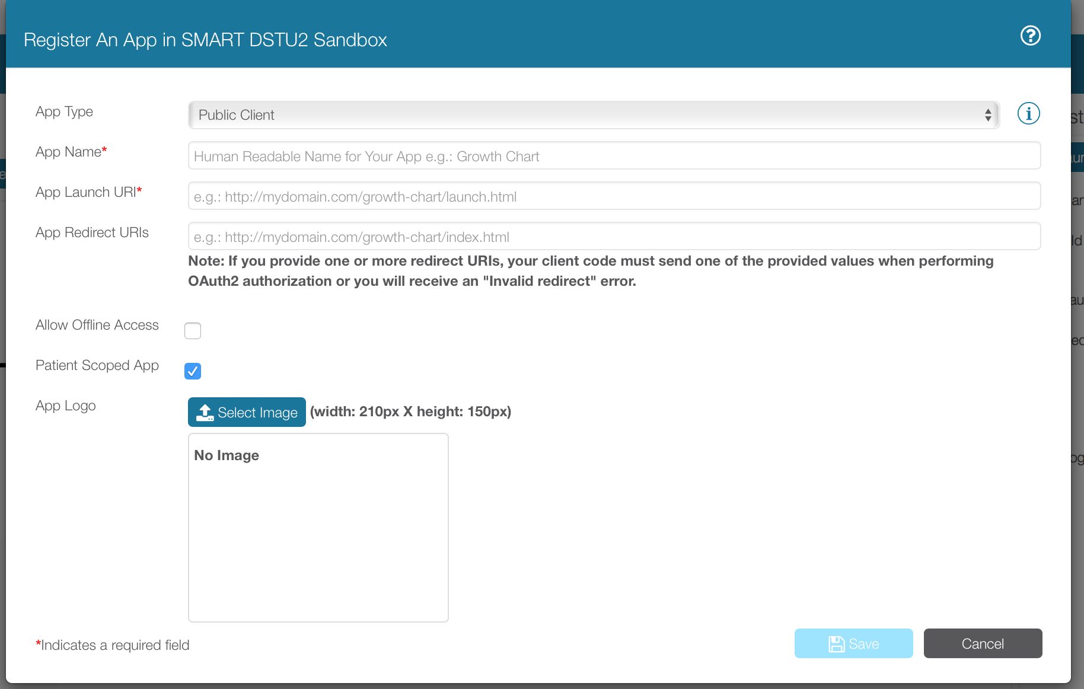

Fill in:

* App Name: a name of your choice
* Launch URI: <http://localhost:8000/launch.html>
* App Redirect URIs: <http://localhost:8000/>

Register the app and grab its “Client Id”

### Sandbox server settings

Access this page from the “Settings” page in the Sandbox:

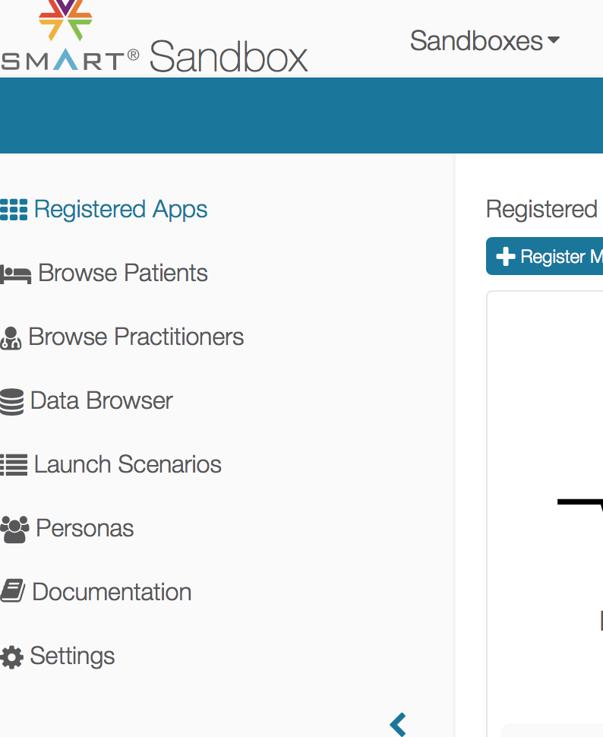

The URLs you see below are the ones you should use in your test program:

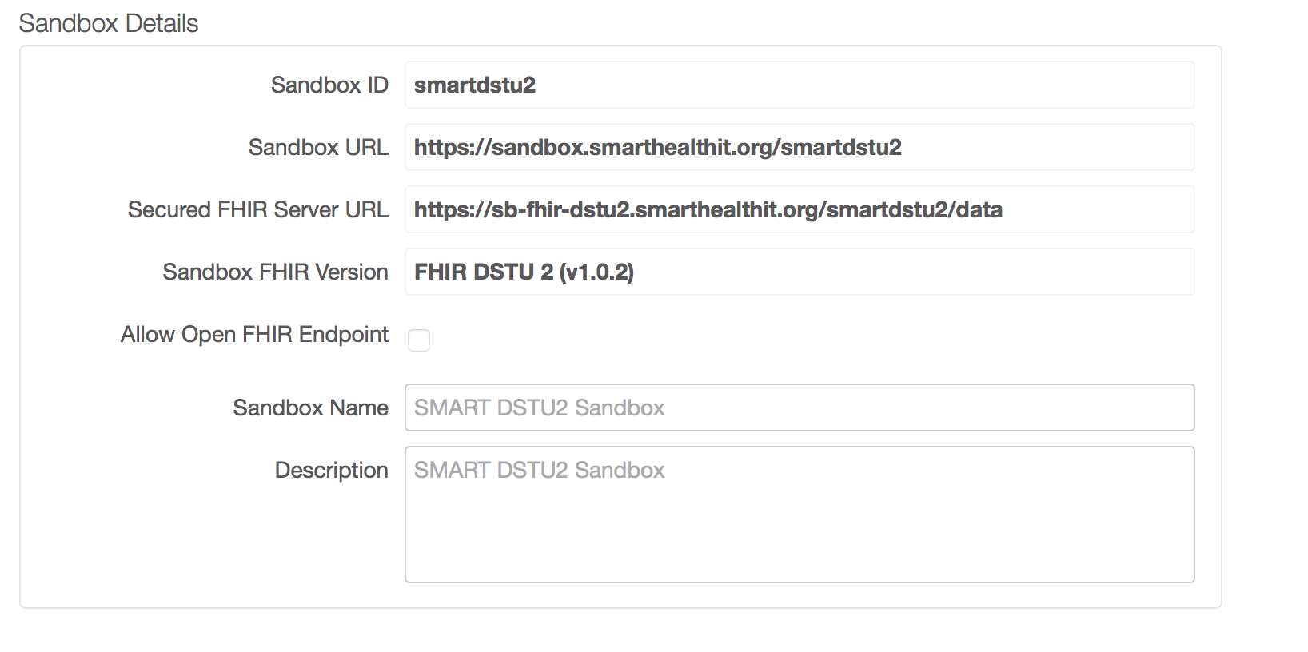

### Get a client ID

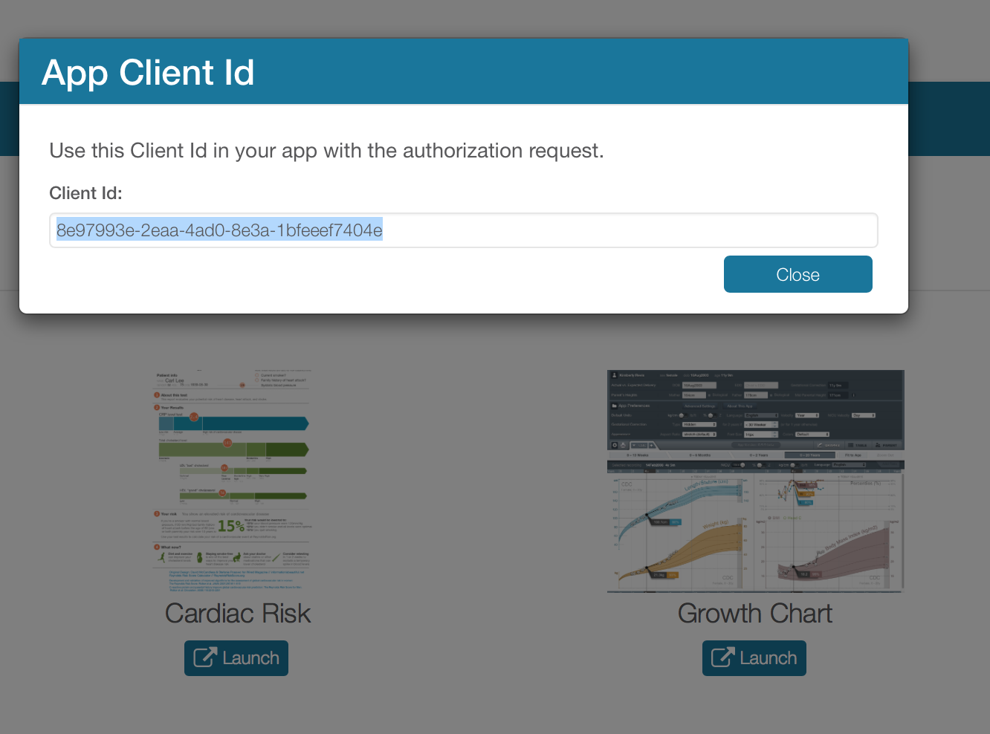

### Set the scope

Go back to your application and edit its “Scope” value:

launch/other launch/patient openid profile user/Patient.read smart/orchestrate_launch user/*.read launch user/*.* launch/encounter patient/*.read offline_access launch/resource patient/*.*

**Reference:** <http://docs.smarthealthit.org/authorization/scopes-and-launch-context/>

### Create the HTML pages

Per the authorization tutorial, you have to create two HTML files: launch.html and index.html

Edit the launch.html and paste into it the client id value you retrieved from the section above (after you registered your test app).

If you are on Mac OS, install NodeJS and then run the http-server on port 8000 (or as you registered/configured your app).

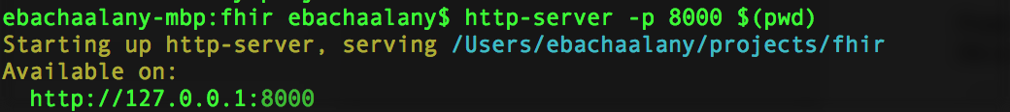

### Launch the application

This is the final step. Your application should be configured somehow like this:

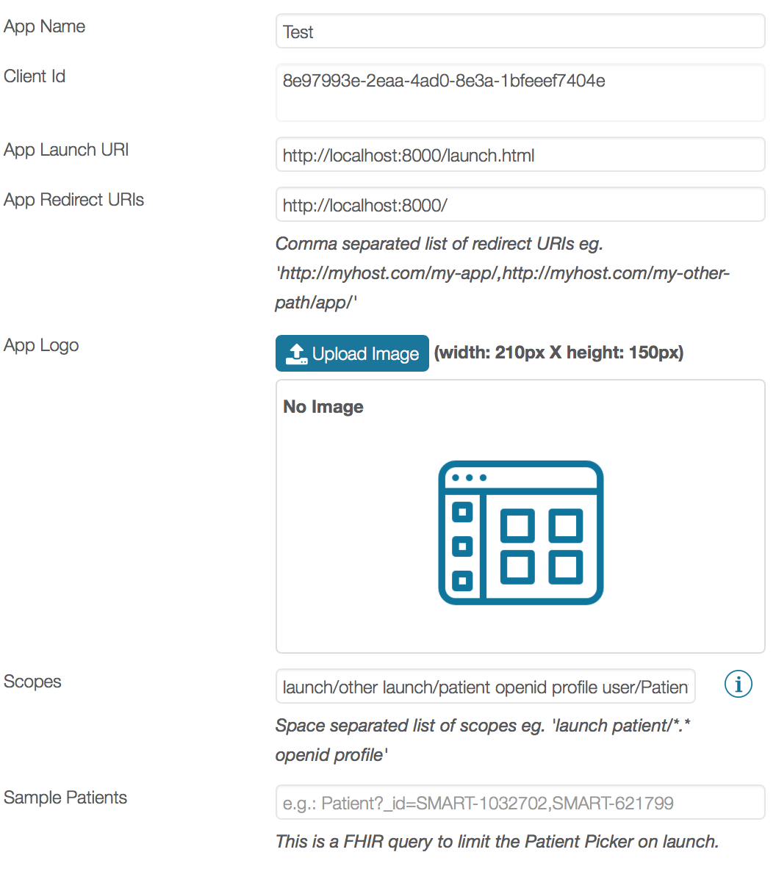

If you have your local web server up and running, then you are ready to launch your app from the sandbox:

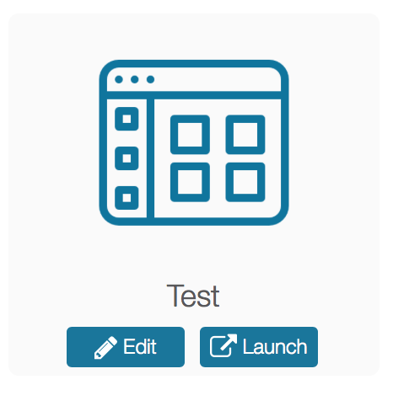

A patient selection dialog should show:

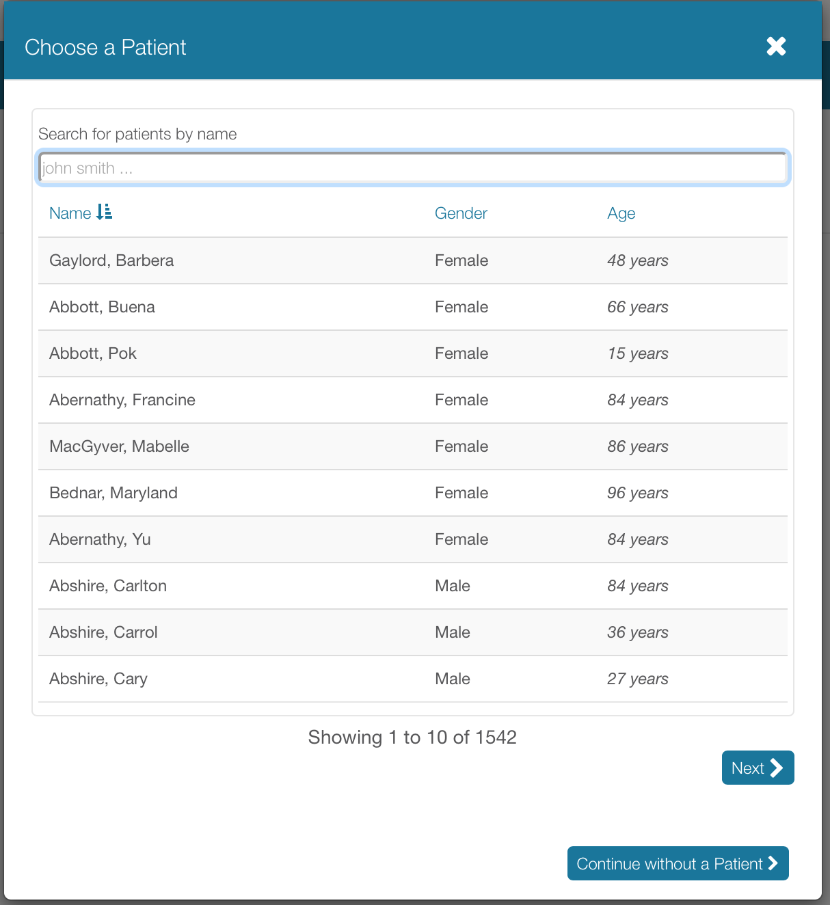

After that, if everything is fine and only once*, then you should approve your application:

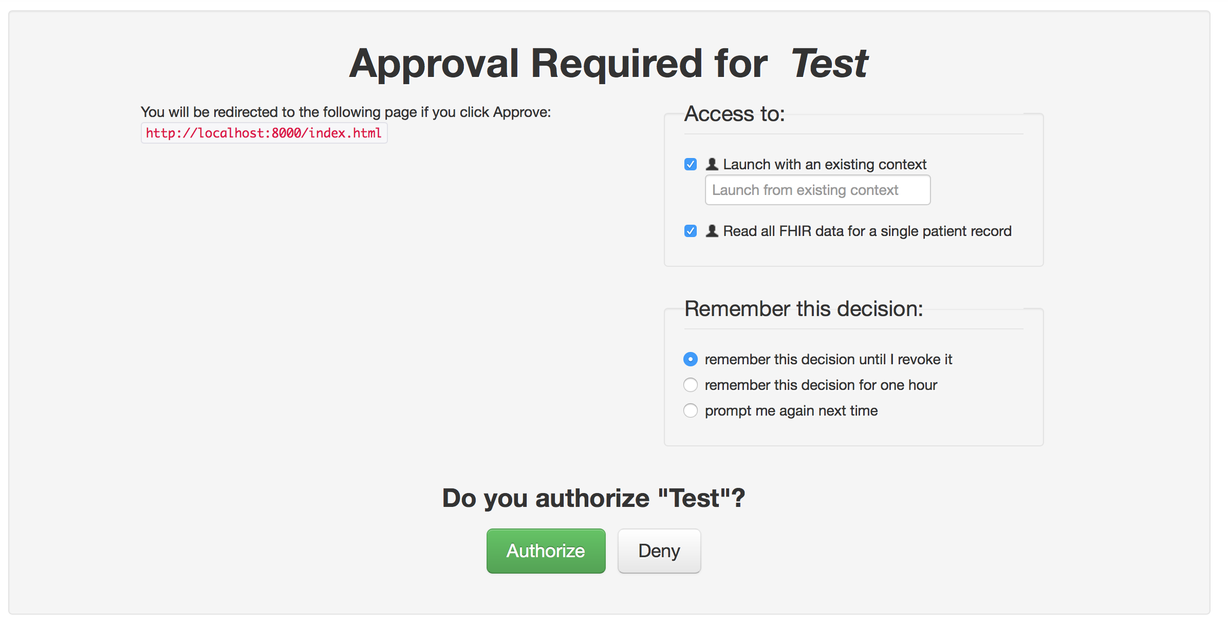

After that, index.html will execute:



# Using the API

Now you can proceed to the following page to learn how to use the APIs instead.

<http://docs.smarthealthit.org/tutorials/testing/>

1. Create the launch.html page. Edit the client_id
2. Create the index.html sample page and voila!

## API libraries

* Python: <http://docs.smarthealthit.org/clients/python/>
* JavaScript: <http://docs.smarthealthit.org/tutorials/javascript/>

# Resources

* Support forum - <https://groups.google.com/forum/#!forum/smart-on-fhir>
* FHIR Client - <https://github.com/FHIR/fhir.js>
* Patient Browser - <https://patient-browser.smarthealthit.org/index.html#/>
* Patient Browser – Source Code - <https://github.com/smart-on-fhir/patient-browser>
* Find a FHIR dev - <https://smarthealthit.org/build-apps/find-a-developer/>
* Not implemented yet - <http://cds-hooks.org/#overview>
* Code and test online with Plunk - <http://docs.smarthealthit.org/tutorials/javascript/> -> <https://plnkr.co/edit/3XQvjlISzPWSBm1VDgM4?p=preview>
* <http://docs.smarthealthit.org/clients/javascript/> 🡪

